
NAMAL UNIVERSITY, MIANWALI
DEPARTMENT OF COMPUTER SCIENCES

TailorEase - Digital Tailoring & Order Management System
Project Proposal
V 1.0
CSC-331 – SOFTWARE ENGINEERING
Submitted To:
Ms. Asiya Batool
By
1 | Amjid Ali | NUM-BSCS-2025-06 | bscs25f06@namal.edu.pk
2 | Ayesha Parveen | NUM-BSCS-2025-13 | bscs25f13@namal.edu.pk
3 | Izhar Ul Haq | NUM-BSCS-2025-22 | bscs25f22@namal.edu.pk
4 | Laiba Zafar Khan | NUM-BSCS-2025-61 | bscs25f61@namal.edu.pk

GitHub Repository: https://github.com/bscs25f61-lgtm/Tailor-Ease
Submission Date: 9th October, 2026
REVISION HISTORY
Date | Version | Description | Approved by
9th October, 2026 | V 1.0 | Project Proposal | Pending

TABLE OF CONTENTS
1. INTRODUCTION: 5
2. PROBLEM STATEMENT: 5
3. PROJECT OBJECTIVES: 5
4. PROJECT SCOPE: 6
5. STAKEHOLDER IDENTIFICATION: 7
6. SOFTWARE DEVELOPMENT METHODOLOGY: 7
7. TOOLS AND TECHNOLOGIES: 7
REFERENCES AND AI USAGE 11

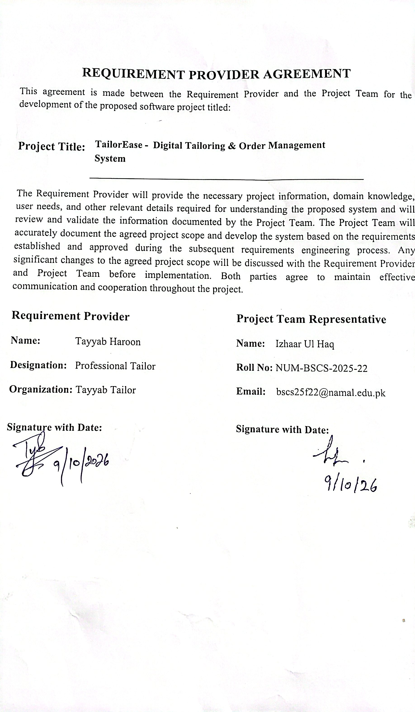

INTRODUCTION:
TailorEase is a system that is being suggested to help a tailoring shop owner manage everyday business tasks. The owner needs to keep track of customer details clothing measurements, garment orders, fitting dates, delivery dates and payment records. Each customer might have measurements and instructions for different clothes so these details need to be simple to store and easy to find. TailorEase will bring together customer profiles, measurements orders and payments, in one place.
The owner will be able to look at order progress and important dates and find customer information easily. TailorEase will be a responsive web application that the owner can use through a web browser on a mobile phone or computer.This project is part of business and service management. It is meant to help the owner organize the shops work and offer service to customers.

PROBLEM STATEMENT:
A tailoring shop owner has to keep track of customer details clothing measurements order instructions, dates, delivery dates and payments. When this information is written by hand or stored in different places it can take extra time to find the right record. The owner may also find it hard to match a customer’s measurements and instructions to the proper order. If an order’s progress or delivery date is not tracked clearly it can be difficult to see which orders are still being prepared or are due soon.
These problems can cause lost records, wrong measurements or order details missed deadlines and confusion about payments or balances that still owe. Customers can be affected by delays or, by garments made with details while the owner may spend more time checking and sorting records. TailorEase is designed to solve these problems by giving one system for managing customer and measurement records tracking orders and important dates and recording payments.

PROJECT OBJECTIVES:

The objectives of the TailorEase system are as follows:
- To develop a customer management module that enables Tayyab Haroon, the shop owner, to add, search, update and view customer records by the end of the project.
- To create a measurement module that stores garment measurements and keeps previous measurement records for each customer.
- To develop an order tracking module that records garment details, fitting and delivery dates and order status from booking to delivery.
- To create a payment module that records cost, advances, additional payments and the remaining balance for each order.
- To test the completed modules with sample records and review the system with the Requirement Provider before final delivery.
- PROJECT SCOPE:
TailorEase will be a prototype for one tailoring shop and will be used by the shop owner only. It will help the owner manage customer information, garment measurements, orders, delivery dates, and payments in one system. The project will focus on the following modules:
4.1 System Features
- Customer Management Module: The owner can add, update, search, and view customer profiles, including contact details and previous orders.
- Measurement Management Module: The owner can save measurements by customer and garment type, add fitting notes, and view previous measurements.
- Order Management Module: The owner can create orders with garment details, quantity, design instructions, trial date, expected delivery date, and order status. The owner can update the status as the order progresses, including when alterations are needed.
- Payment Management Module: The owner can record the total price and payments received for each order and view the remaining balance.
- Dashboard Module: The owner can view active orders, upcoming and overdue deliveries, and unpaid balances.
4.2 Project Limitations and Exclusions
- The system is designed for one tailoring shop and one owner account. It will not include staff accounts or staff access levels.
- Customers will not log in or place orders through the system. The owner will enter their information.
- The first version will not include multiple shop branches, online payment services, automatic SMS or WhatsApp messages, payroll, or advanced inventory management.
- The owner will enter measurements manually. The system will not take measurements automatically or decide tailoring requirements.

- STAKEHOLDER IDENTIFICATION:

The following stakeholders are related to the TailorEase system.
Table 1: Stakeholders and Their Roles in the Proposed System
Stakeholder | Role | Interaction with System
Tayyab Haroon | Shop Owner, Requirement Provider, and main and only system user | Uses the owner account to manage customer details, measurements, orders, fitting and delivery dates, payments, and dashboard information. He also explains the current tailoring process and provides feedback on the system.
Customer | Indirect stakeholder and service recipient. | Shares necessary details and garment instructions with Tayyab Haroon. Customers do not log in or enter information in the system.
Student Project Team | Developers | Collects requirements, designs, develops, tests, and documents the system. The team is not a regular user of the completed system.

- SOFTWARE DEVELOPMENT METHODOLOGY:

6.1 Methodology to Be Used
TailorEase will use the Agile Scrum methodology. The four team members will work in two-week sprints. Each sprint will have planned tasks and a review of the work completed. TailorEase is planned for one shop owner and will not include staff accounts.

6.2 Why Agile Scrum Is Suitable
TailorEase has separate modules for customer records, measurements, orders, and payments. Scrum allows the team to develop these modules in steps and review them with the shop owner during the project. The team can record feedback and plan suitable changes for later sprints [1].

6.3 How Scrum Will Guide the Project
- Planning: The team will list project tasks and arrange them by priority.
- Requirements analysis: The team will discuss the owner’s current process and confirm requirements with Tayyab Haroon.
- Design: The team will prepare the database plan and interface design before building the system.
- Implementation: The team will develop TailorEase module by module during the sprints.
- Testing: The team will test each module and check that the connected system works as expected.
- Delivery: The team will make final corrections, prepare project documents, and demonstrate the completed system.
The team will track tasks in a project board and store project files in the GitHub repository. Team members will review progress monthly, and the team will review completed work at the end of each sprint. The team will meet with the Requirement Provider about once each month and keep handwritten meeting minutes. Requested changes will be recorded, discussed with the owner, and added to the task list if they fit the agreed scope and schedule.

6.4 Tentative One-Year Gantt Chart
The project is planned to be completed within one year. The tentative schedule and major milestones are given below.
Tentative Gantt Chart:
Table 2: Tentative Gantt Chart
Activity | M1–2 | M3–4 | M5–6 | M7–8 | M9–10 | M11–12
Planning and Requirement Analysis | ■
System and Database Design |  | ■
System Development |  |  | ■ | ■
Testing and Feedback |  |  |  |  | ■
Improvements and Final Delivery |  |  |  |  |  | ■
Major Milestones:
- Month 2: Requirements completed.
- Month 4: System design completed.
- Month 8: Main modules developed.
- Month 10: Testing and feedback completed.
- Month 12: Final system and documentation delivered.

Reference:
[1] K. Schwaber and J. Sutherland, The Scrum Guide: The Definitive Guide to Scrum: The Rules of the Game, Nov. 2020. [Online].
Available: https://scrumguides.org/docs/scrumguide/v2020/2020-Scrum-Guide-US.pdf.

7. TOOLS AND TECHNOLOGIES
The TailorEase system will use suitable tools and technologies for system development. These tools will help the team design the user interface, manage data, develop system features, and work together. The proposed tools and their purposes are given below.
Table 3: Proposed Tools and Technologies
# | Tools and Technology | Purpose
1 | HTML | To create the structure of the system's web pages.
2 | CSS/Bootstrap | To style the user interface and make the pages responsive for mobile phones and computers.[2]
3 | JAVA servlets and JSP | To develop system’s functions and to process user requests.
4 | MySQL and SQL | To store customer details, measurements, orders, and payment records.
5 | Visual Studio Code | To write and edit the project code.
6 | draw.io | To create use case and database diagrams.
7 | Git and GitHub | To manage code changes and support teamwork.
8 | Web Browser | To run and test the system.
9 | MySQL Connector/J (JDBC) | To connect the Java system with the MySQL database.
10 | Apache Tomcat | To run the java web application.

REFERENCES AND AI USAGE
ChatGPT was used to check the proposal structure and formatting, improve some wording, and suggest development tools. The team reviewed and edited the content and will confirm the system requirements with Tayyab Haroon.
[1] K. Schwaber and J. Sutherland, “The Scrum Guide: The Definitive Guide to Scrum,” November 2020. [Online].
Available: https://scrumguides.org/docs/scrumguide/v2020/2020-Scrum-Guide-US.pdf. [Accessed: October 9, 2026].
[2] Bootstrap, “Breakpoints,” Bootstrap v5.3 Documentation. [Online].
Available: https://getbootstrap.com/docs/5.3/layout/breakpoints/. [Accessed: October 9, 2026].
YouTube Link:
https://youtu.be/8dGdIcyDk1w?si=G8t5dJa_FyAIeZuN
ChatGPT Link:
https://chatgpt.com/share/6ac8c96b-ae9c-83ee-b0d6-db9dfd62d104
AI Prompt Summaries
https://chatgpt.com/share/6ac8c96b-ae9c-83ee-b0d6-db9dfd62d104
- “Hamare TailorEase project proposal ko mam ke diye hue template aur Milestone 1 requirements ke mutabiq check karo. Simple English mein headings aur formatting ko organize karne aur missing cheezen batane mein help karo.”
- “Suggest simple and suitable development tools for TailorEase, a web-based tailoring system used by one shop owner. Explain the purpose of each tool in simple English.”
- “Hamare proposal ke headings aur formatting ko mam ke template ke mutabiq check karo aur jo cheezen missing ya inconsistent hain unki list do.”
- “Please check our TailorEase proposal with the milestone requirements and point out anything missing or unclear.”

